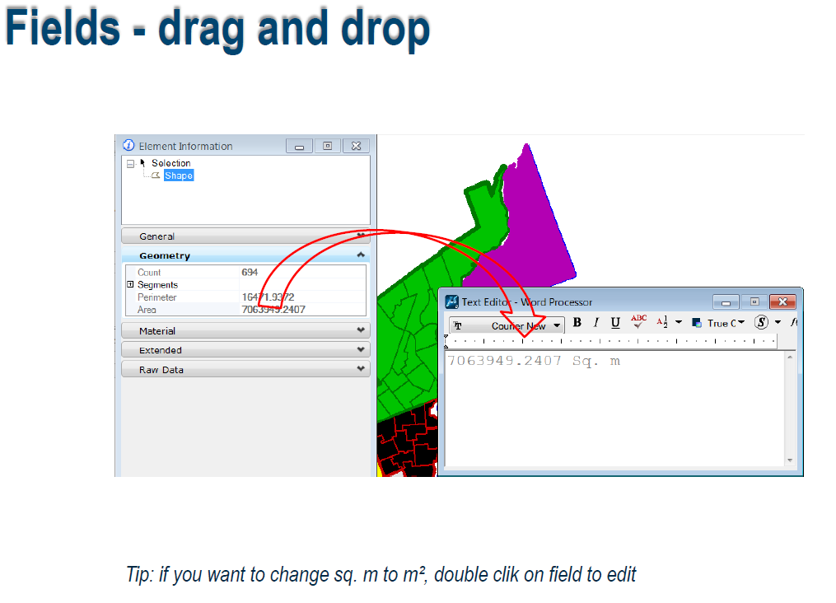
Choose the field you want in your text from the Element Information dialog, and drag and drop it into the text editor. To change the presentation, double click the field and make your changes in the Field Editor.

