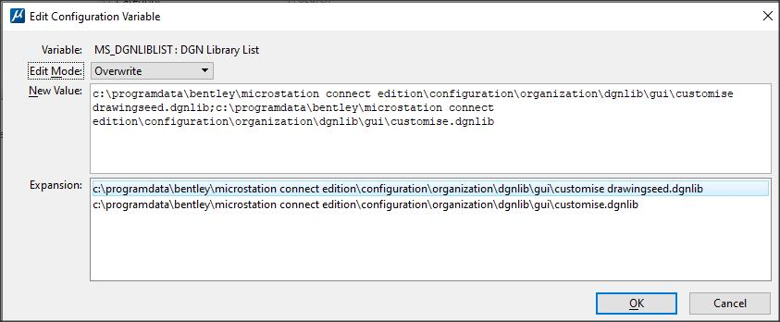
This is where my menus are stored.

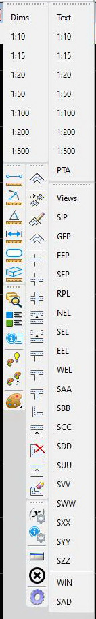
This is a series of menus located on the right side of the left screen ie in the middle so that access is quick and easy.
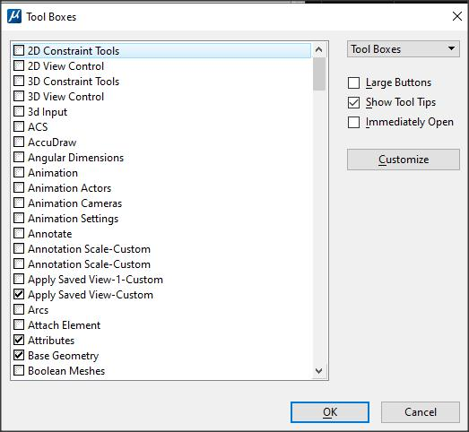
Access to predetermined views. Select and data point screen. The abbreviations are designed to be consistent and self-evident ‘GFP’ Ground Floor Plan
(it only works on the default model)
Text and Dimension that are regularly used.
PTA brings up the ‘place text along’ dialog
Quick access to Text Box dialog and thus customisation and creation of text boxes and menus
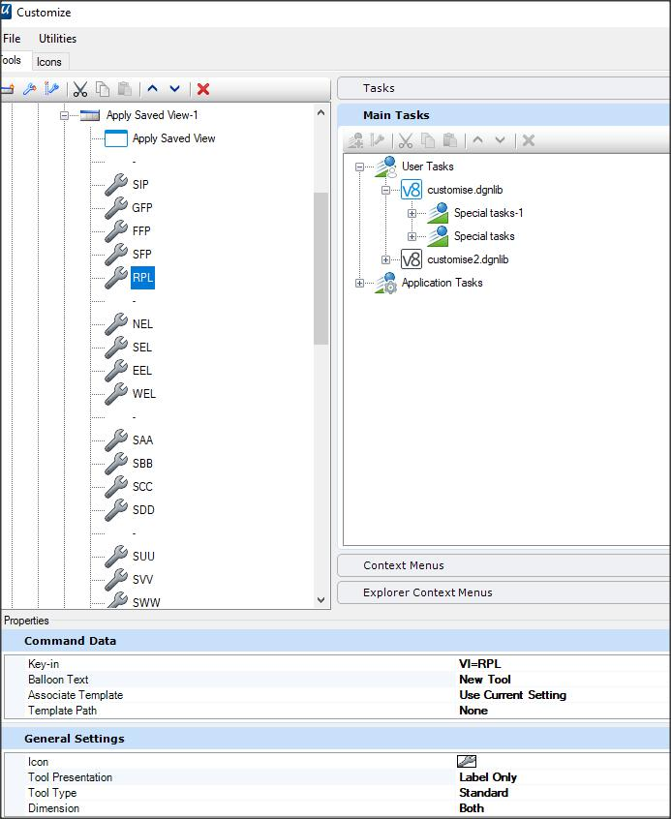
The customisation dialog showing the key-in to restore a view. You need to data point after selection to select a screen.
The Menu abbreviations are as follows: (These can be changed to suit your standard views)
SIP Site Plan SAA Section AA SZZ Section ZZ
GFP Ground Floor Plan SBB Section BB D01 Detail 01
FFP First Floor Plan SCC Section CC D02 Detail 02
SFP Second Floor Plan SDD Section DD D03 Detail 03
RPL Roof Plan SUU Section UU D04 Detail 04
NEL North Elevation SVV Section VV D05 Detail 05
EEL East Elevation SWW Section WW D06 Detail 06
SEL South Elevation SXX Section XX
WEL West Elevation SYY Section YY
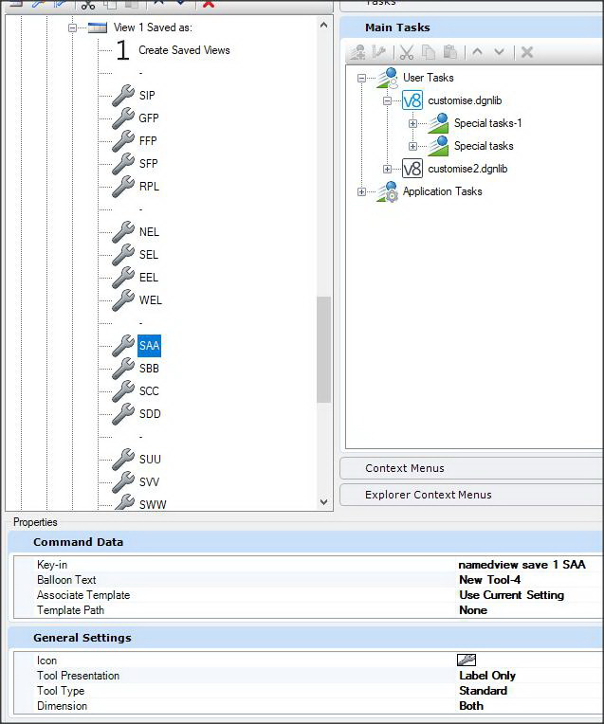
This is the save the view on Screen 1. As this operation is used relatively infrequently these menu items are accessed via the ‘reset’ popup menu.
These items were not a permanent on a pulldown or toolbox or menu, rather to the slightly less accessible ‘reset’ popup menu.
It should be noted that using the space bar to (used to) initiate the popup menu conflicts with toggling the accudraw readout. This conflict occurred where the ‘y’ coordinate toggles between linear and angular. In Connect use short cut ‘m’ or keyin ‘accudraw mode toggle’
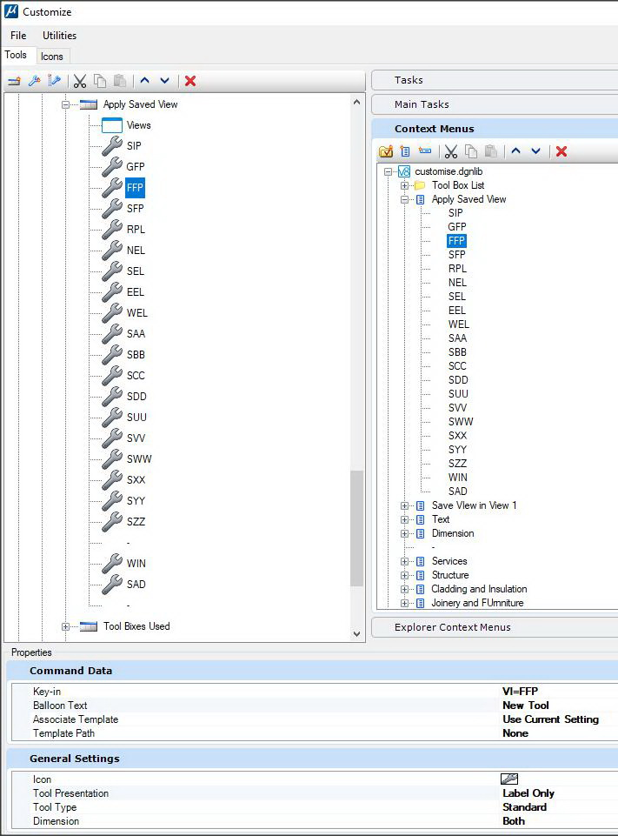This is the Context menu. It was created in the left pane and copied to the ‘Context Menus’ section on the right side.

